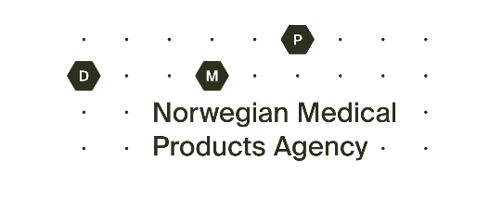

Application – batch specific variation

Information about the medicinal product
Name, strength, pharmaceutical form:
Active substance:
Pack size: | Number of packages:
MA number: | Batch number:

Information about the deviation
The deviation is related to:
quality
delayed implementation of product information
Background for the deviation:

If relevant, when should variation in product information have been implemented? Please state date:
Expected implementation date:

Information about the action to be taken
What actions have been made and what does the applicant suggest to solve the delay:

Will a rejection cause a shortage situation in Norway? Yes No
Are there similar medicinal products on the Norwegian market? Yes No

Attachments
Batch specific variation regarding delayed implementation of product information
Last approved package leaflet with tracked changes and/or mock-ups
Batch specific variation regarding quality
Risk assessment based on relevant competent evaluation for the sake of supporting the application.

Information about the marketing authorisation holder or local representative
Company name:
Contact person:
E-mail:

Invoice
Company name and address:
Contact person:
E-mail:

Please submit this application form together with last approved package leaflet and/or mock-ups and/or risk evaluation to post@noma.no

