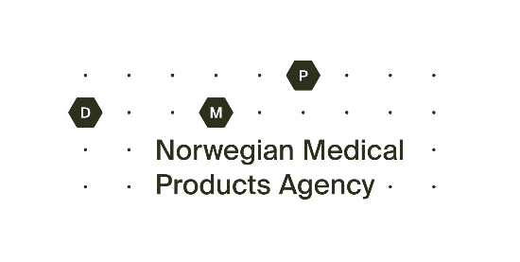
Application for approval of chemical disinfectant
for technical use in health care and nursing

Send the application to the Norwegian Medical Products Agency (NOMA), desinfeksjonsmidler@noma.no.
Fees will be billed by NOMA.

Information about the applicant
Applicant's name and postal address:

Manufacturer:

Contact person for the applicant:

Date:

Applicant's signature:

If the product is supplied in more than one strength or formulation, an application for each strength or form must be submitted.

Product information
Name:

Dosage form:

Strength:

Reg. No:

Disinfective substances:

Concentration indicated by weight/volume:

Packages:

Attachments that must be attached to the application:
- Description of the product on form from NOMA (on the next page)
- Labelling
- Documentation
- Summary of documentation

DESCRIPTION OF THE PRODUCT – Appendix to application for approval of disinfectant for technical use in health care and nursing

Chemical information - composition of the product
Disinfective substance(s) | Concentration (preferably weight/vole)
Excipients:

Other comments:

Chemical information - additional information about the product
The preparation is ready to use
Yes
No
Must be diluted
Yes
No
Dilutant:

Dilutant ratio:

Shelf life of concentrate at room temperature:

Shelf life of use dilution:

Packaging (material):

Recommended tub for dilution:

Area of use (Disinfecting effect and material impact of the product considered as a whole)
Metal and glass instruments
Suitable
Not suitable
Rubber and plastic remains
Suitable
Not suitable
Endoscopes, optical instruments
Suitable
Not suitable
Floor, walls, furniture, surface disinfection
Suitable
Not suitable
Specially suited for:

Has been in common use in health care in Norway?
Yes
No

If so, since year:

Has been in common use in other countries?
Yes
No

If so, which ones:

Used in the food industry?
Yes
No

Disinfectant effect - satisfactory effect (effect on microorganisms of ready-to-use solution, used according to instructions for use)
Gram-positive bacterias  Yes  No  Not documented | Gram-negative bacterias  Yes  No  Not documented |  | Myco bacterias  Yes  No  Not documented
Bacterial spores  Yes  No  Not documented | Virus  Yes  No  Not documented |  | Fungus  Yes  No  Not documented
Algae  Yes  No  Not documented |  | Other:

Disinfecting effect – effect (Effect on microorganisms of ready-to-use solution, used according to instructions for use)
Growth innhibitorry  Yes  No | Microbiocidal  Yes  No
Mechanism of effect: | Optimal pH
Contact time,
minimum °C at room temperature °C

minimum °C at different temperature °C
Effect reduced by:

Organic matter
Yes
No

Inorganic salts, hard water
Yes
No

Detergents, phosphate/fatty acids
Yes
No

Other:

Toxicological information - concentrated product
Low toxic  Highly toxic |  | Any information on minimum toxic dose or maximum nontoxic dose to humans:
Important symptoms of toxicity: | First aid: |  | Antidote:

Toxicological information - ready-to-use solution
Low toxic
Highly toxic
Long-term exposure toxic effects:

Irritating/corrosive on skin
Yes
No
Irritant on mucosa
Yes
No
Vapor from preparation irritating to eye/respiratory tract
Yes
No
May cause sensitization
Yes
No
Is a similar product registered as a medicinal product?
Yes
No
Annoying smell of ready-to-use preparation?
Essential
Weak
Nobody
Other information:

Special tests for substances in the preparation
Substances | Mutagenic test |  | Method
 | Yes | No
 | Yes | No
 | Yes | No
Substances | Carcinogenic test |  | Species
 | Yes | No
 | Yes | No
 | Yes | No
Substances | Chronic toxicology |  | Species
 | Yes | No
 | Yes | No
 | Yes | No
Substances | LD50 (mg/kg) |  | Species

Environmental toxicology information
Biodegradability of the substances
Substances | Rappid (days) | Slow (months) | Stable
Other environmental toxicological information:

Material impact, surface effect

Material impact of ready-to-use solution with regular use according to the instructions for use:

Metal
Affected
Not affected

Plastic
Affect
Not affected

Rubber
Affected
Not affected

Lenses
Affected
Not affected

Fiber optic instruments
Affected
Not affected

Textiles
Affected
Not affected

Paint
Affected
Not affected

Discoloration (bleaching)
Affected
Not affected

Discoloration
Affected
Not affected
Other:

Deposition (for example, precipitation of polymeric compounds) on disinfected objects:

