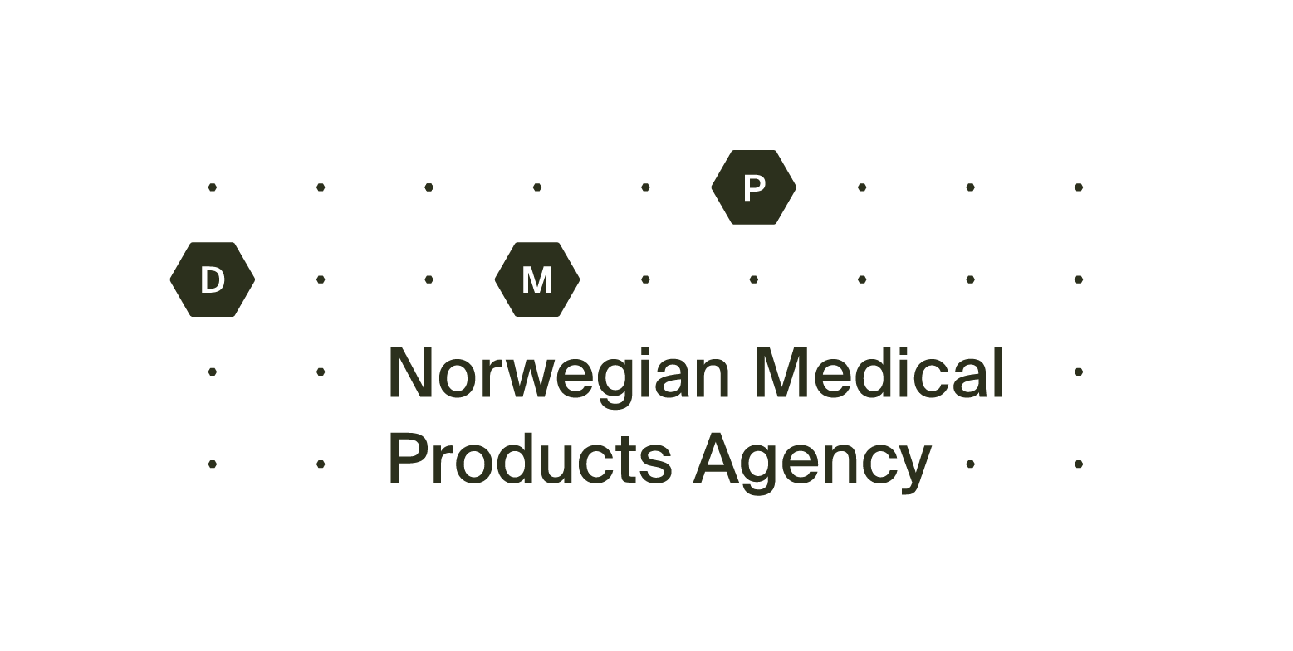
Renewal Application for marketing authorisation - parallel imported medicinal product
The completed form must be sent to: post@dmp.no.

Information about the medicinal product
Name of the product:
Pharmaceutical form and strength:
Marketing Authorisation Number (MT(PI)no.):
Exporting state:
Name of product in the exporting state:
All valid package sizes:

Information about the Holder of the Marketing Authorisation for parallel imported medicinal product
Company name:
Address:
Invoice address:

Contact information

Name:

Phone:

E-mail:
Date: | Signature by applicant:

